**UNIEATS**

**divplusplus**

**API Integrations-5A**

**Events and Activities API – 3A-One For All**

We will integrate our dining services application with the campus events and activities app through their API, allowing us to pull event data such as locations and times and list of the restaurants to specific events. This integration ensures that users can see dining options available at each event in real-time, enhancing their experience by providing seamless access to viewing which events will have which restaurants and as a stretch goal to allow the user to order from the restaurants that are catering at the events through our app.

<https://eventsapi3a.azurewebsites.net/>

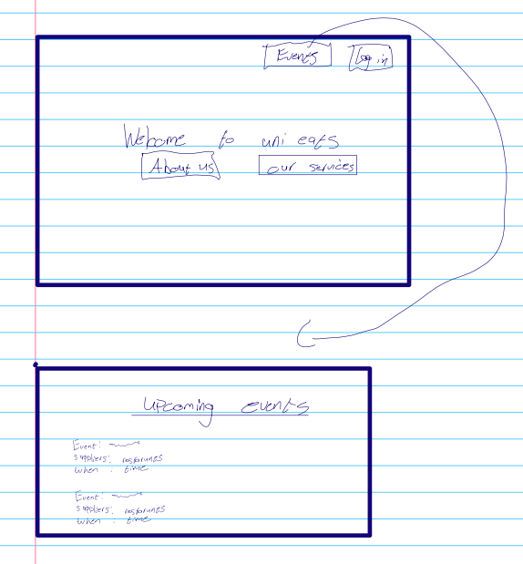

As of 01/10/2024, the events team said that they’re having some technical difficulties however we can fetch from their upcoming events API which is what we have done so far. To mock data, we are going to add a restaurant column and randomly generate a restaurant for an event.

**Transport API-1A-K3rn3l P@n!c**

We will integrate a navigation API into UniEats to enhance the user experience by providing seamless directions to restaurants. This integration will involve adding a "Get Directions" feature on the restaurant details page, allowing users to receive route information based on their location. The directions will be displayed using an external map service, enabling users to easily find their way to selected restaurants. We are hoping to be able to send the coordinates of the restaurant in the fetch and then will be returned a map with directions to the selected restaurant. As a stretch goal we will be fetch the scooter hub locations to provide to the users as they can use the scooters to get to the restaurants in a faster manner.

[http://ec2-52-40-184-137.us-west-2.compute.amazonaws.com](http://ec2-52-40-184-137.us-west-2.compute.amazonaws.com/)

As of 01/10/2024, this group have not given us access to their API so we have said that link is currently unavailable but once we get access to it then we will have a map coming up showing directions to the restaurant.

